MAIN PAGE

SIDING & SOFFIT
Industrial / Residential / Commercial
Enhance the aesthetic and functional appeal of your industrial, residential, or commercial property with our high-quality siding solutions. At Cladcan, we offer a wide range of siding materials designed to meet diverse architectural needs and performance requirements. Choose from an impressive selection of solid colors and realistic wood-look finishes to achieve the perfect visual effect for your project. Our products ensure durability, energy efficiency, and exceptional visual appeal, making them ideal for any building project.
Find the ideal match for your project with our impressive array of offerings!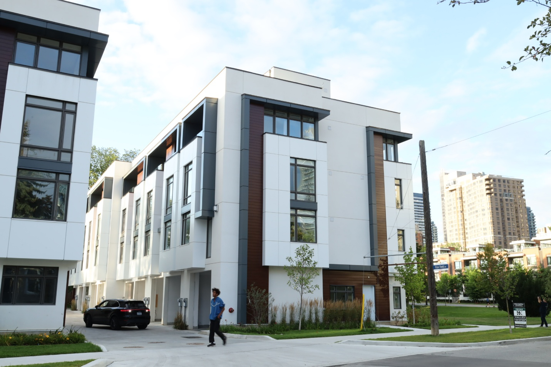

STEEL SIDING & SOFFIT MENU ICON (PREVIEW)

Steel Siding & Soffit
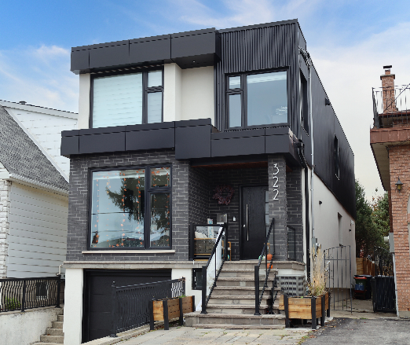
Durable, stylish, and cost-effective, metal siding panels offer a modern and long-lasting solution for residential and commercial projects. (Learn More- Expand)
Expanded … Durable, stylish, and cost-effective, metal siding panels offer a modern and long-lasting solution for residential and commercial projects. Made from high-quality steel, these panels provide excellent protection against harsh weather, fire, and pests while enhancing energy efficiency. Their low maintenance requirements and longevity make them a budget-friendly choice over time. With a variety of profiles, finishes, and colors available, metal siding delivers both aesthetic appeal and structural resilience, making it a smart investment for any building.
Curious about the advantages of steel siding? Visit our blog to explore the compelling reasons why this choice stands out for homeowners seeking durability and style.
Speak with an Expert
Get personalized advice and expert guidance to achieve your project goals with confidence.

1- GALANTA MENU ICON (PREVIEW)

Galanta Steel Siding & Soffit
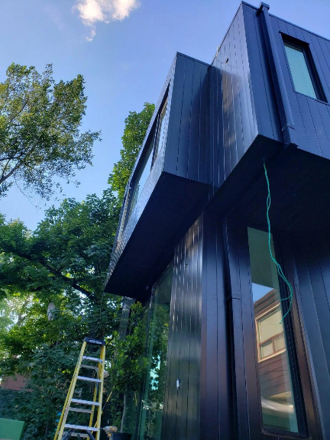
Galanta® Hidden Fastener Steel Siding and Soffit offers durable protection against extreme weather while giving your home or business a refined, modern look that boosts curb appeal and long-term value.. (Learn More / Expand)

- 1 GALANTA PAGE (EXPANDED)
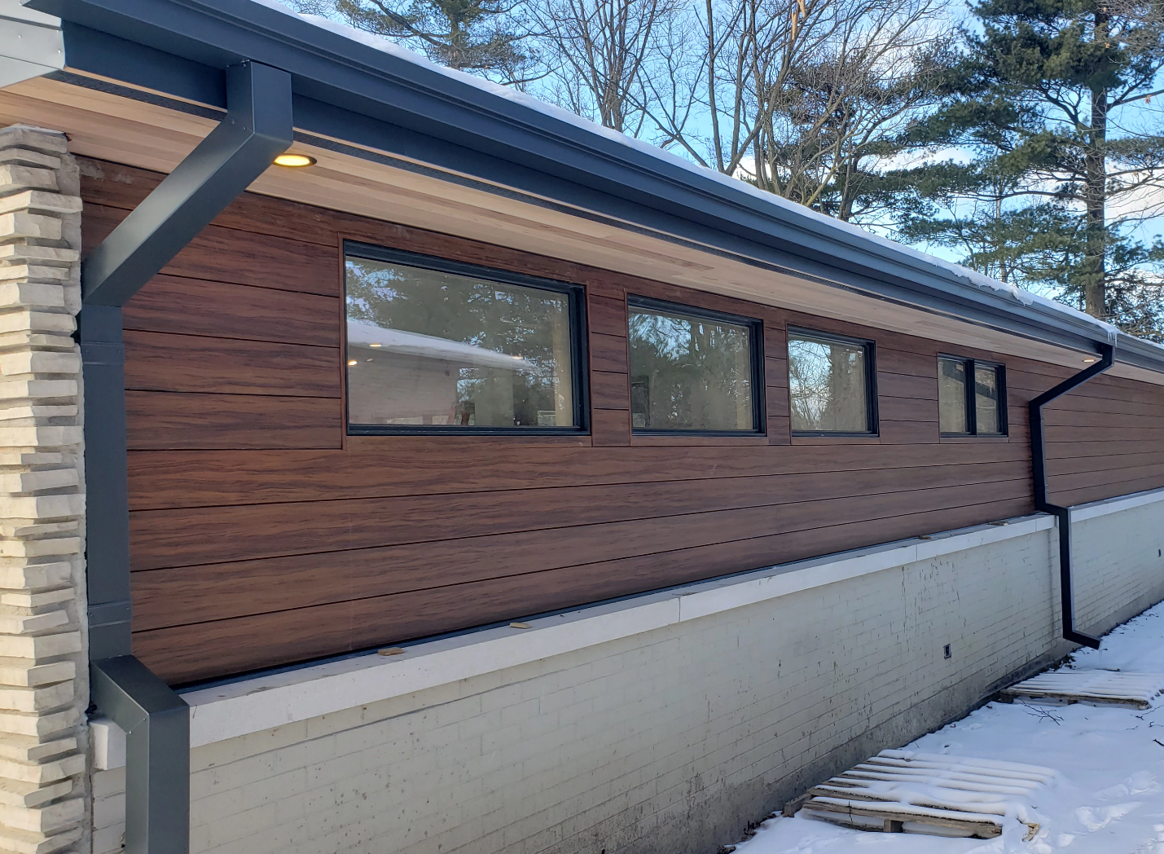
Expanded … Galanta® Hidden Fastener Steel Siding and Soffit offers durable protection against extreme weather while giving your home or business a refined, modern look that boosts curb appeal and long-term value.
Each panel measures 6¼ inches wide by 12 feet long and is packaged in boxes of 8, covering 50 square feet per box. Galanta® siding is available in solid colors, shaded wood grain, and classic wood grain finishes, and can be installed either vertically or horizontally. It pairs seamlessly with a range of exterior materials—including brick, stone, concrete, or glass—making it suitable for both contemporary and traditional architectural designs.

Engineered with a concealed fastening system and a perforated strip for simplified installation, the panels are end-notched for clean, continuous overlapping. The embossed wood grain texture adds visual appeal and increases panel rigidity, helping to eliminate oil canning on the flat surfaces.

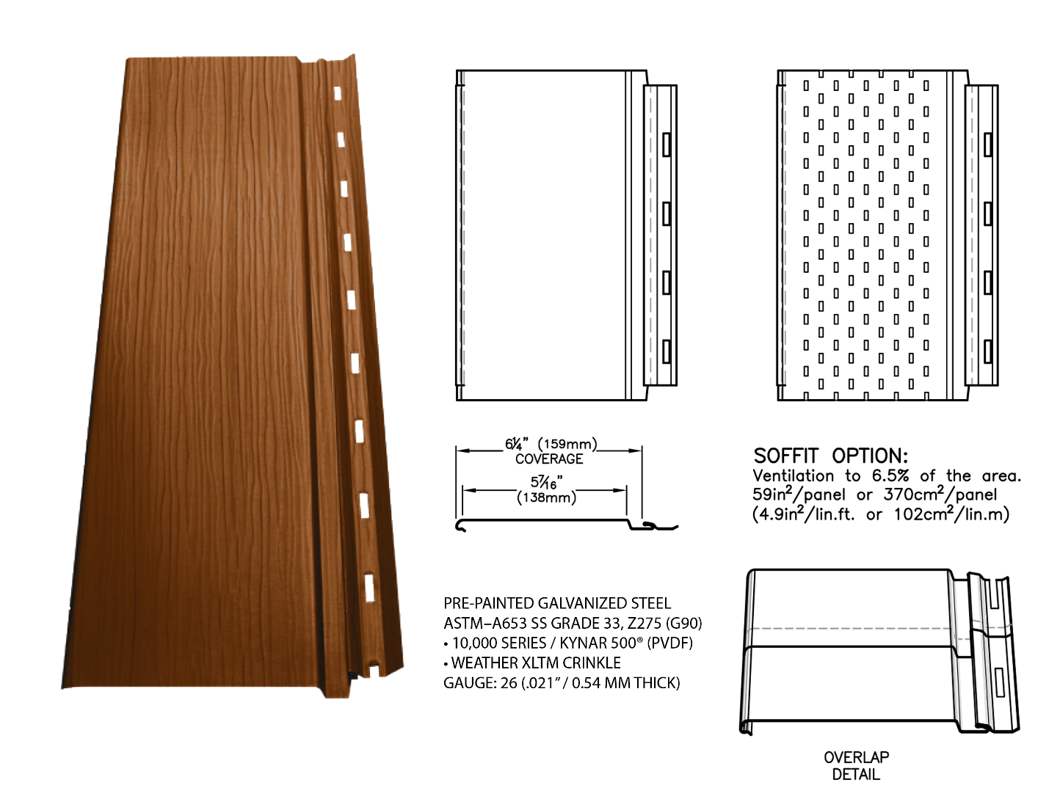

Why Galanta® Siding Outperforms Other Cladding Options
Galanta® steel siding is up to 50% lighter than fiber cement and pressed wood siding, making it significantly easier to handle and install.
Unlike vinyl siding, Galanta® won’t turn brittle or crack in freezing temperatures—ensuring long-lasting performance through harsh winters.
Unlike wood siding, it never needs to be stained or painted. And because it’s moisture-resistant, it won’t rot like wood or pressed wood products.
Unlike aluminum and vinyl, Galanta®’s high-quality paint finish resists fading and chalking—and it’s backed by a transferable 40-year limited warranty for added peace of mind.
Finally, while wood and pressed wood are non-recyclable and contribute to deforestation, Galanta® siding is made from steel—the most recycled and recyclable material on the planet.

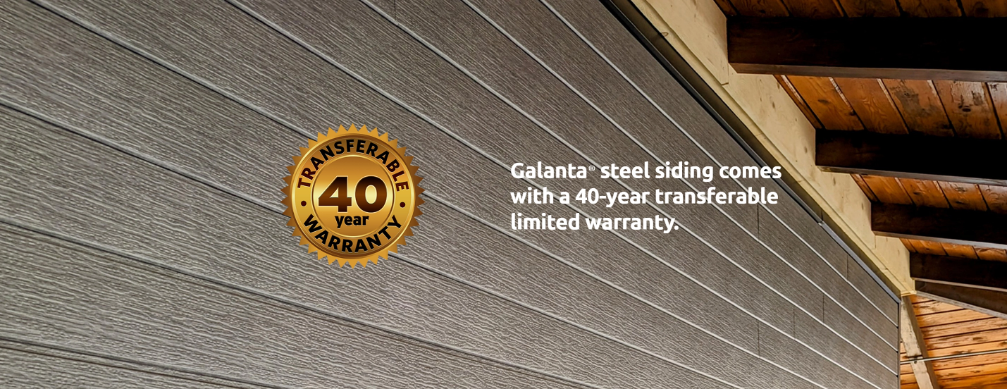
Explore Our Stylish Color Selection
Long-Lasting Finish You Can Count On
Unlike aluminum or vinyl siding, Galanta®’s durable paint finish won’t crack, peel, flake, or fade over time. It’s protected by a 40-year transferable limited warranty for lasting peace of mind.

Offered in a variety of modern, on-trend shades, our palette is designed to elevate your property’s look while adding to its overall value.

